Triangular Cupola
# Source: AI Source: Provided by: [Data Path: Persons Table -> ID Column: 1, Name_En Column: Motasem Essam] -> From: [ChatGPT] on [7/25/2026]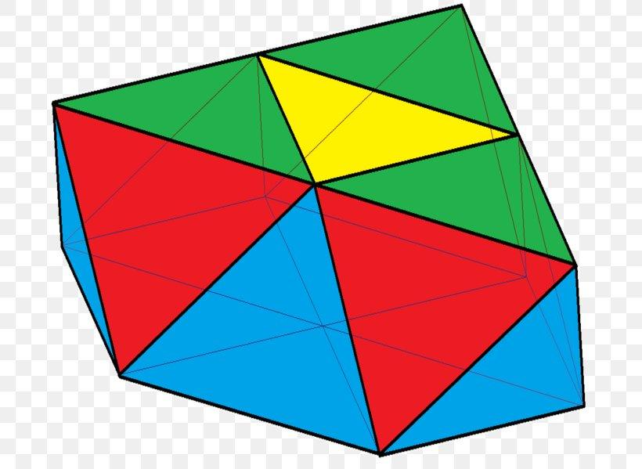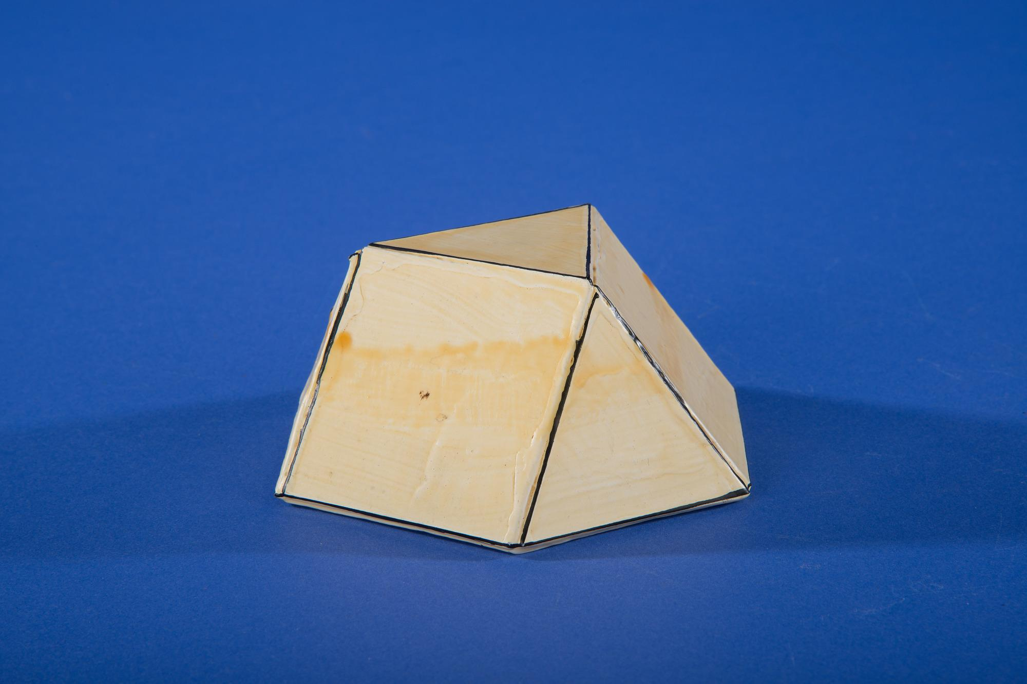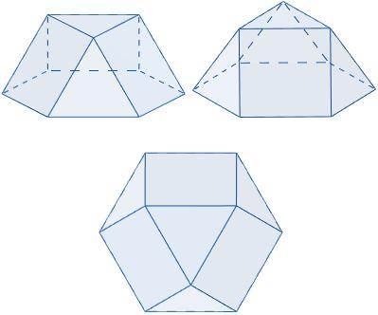

Definition
# Source: AI Source: Provided by: [Data Path: Persons Table -> ID Column: 1, Name_En Column: Motasem Essam] -> From: [ChatGPT] on [7/25/2026]
A Triangular Cupola is a convex polyhedron consisting of:
- One triangular upper base.
- One regular hexagonal lower base.
- Three equilateral triangular lateral faces.
- Three square lateral faces.
The two bases are parallel, and the triangular and square lateral faces alternate around the sides of the cupola.
The Triangular Cupola is one of the Johnson solids, specifically Johnson solid J3.

Geometric Structure
# Source: AI Source: Provided by: [Data Path: Persons Table -> ID Column: 1, Name_En Column: Motasem Essam] -> From: [ChatGPT] on [7/25/2026]
- Upper Base: An equilateral triangle.
- Lower Base: A regular hexagon.
- Lateral Faces: Six faces arranged alternately:
- 3 equilateral triangles.
- 3 squares.
- Arrangement: The triangular base is positioned above the hexagonal base, with alternating triangular and square faces connecting their edges.

Face Composition
# Source: AI Source: Provided by: [Data Path: Persons Table -> ID Column: 1, Name_En Column: Motasem Essam] -> From: [ChatGPT] on [7/25/2026]
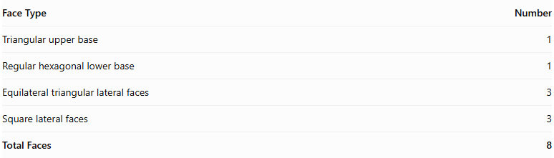
Face Type | Number
Triangular upper base | 1
Regular hexagonal lower base | 1
Equilateral triangular lateral faces | 3
Square lateral faces | 3
Total Faces | 8

Mathematical Properties
# Source: AI Source: Provided by: [Data Path: Persons Table -> ID Column: 1, Name_En Column: Motasem Essam] -> From: [ChatGPT] on [7/25/2026]
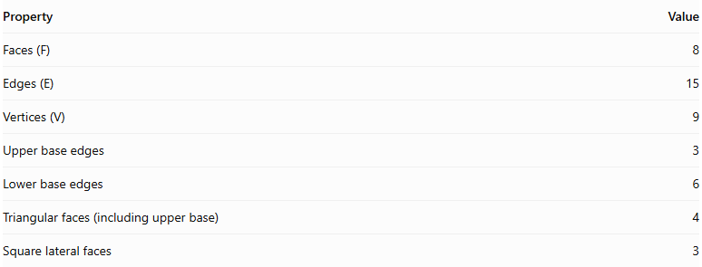
Property | Value
Faces (F) | 8
Edges (E) | 15
Vertices (V) | 9
Upper base edges | 3
Lower base edges | 6
Triangular faces (including upper base) | 4
Square lateral faces | 3
Euler's Formula:
$$V-E+F=2$$
$$9-15+8=2$$
<badge color="success">Euler's formula verified</badge>

Geometric Characteristics
# Source: AI Source: Provided by: [Data Path: Persons Table -> ID Column: 1, Name_En Column: Motasem Essam] -> From: [ChatGPT] on [7/25/2026]
- The triangular and hexagonal bases are parallel.
- The upper triangular base has 3 vertices.
- The lower hexagonal base has 6 vertices.
- The lateral faces alternate between triangles and squares.
- The solid has rotational symmetry of order 3.
- All faces are regular polygons, and all edges have equal lengths in its Johnson solid form.

Constructing Triangular Cupola in Solid Geometry

Geometric Instruments Used
# Source: AI Source: Provided by: [Data Path: Persons Table -> ID Column: 1, Name_En Column: Motasem Essam] -> From: [ChatGPT] on [7/25/2026]
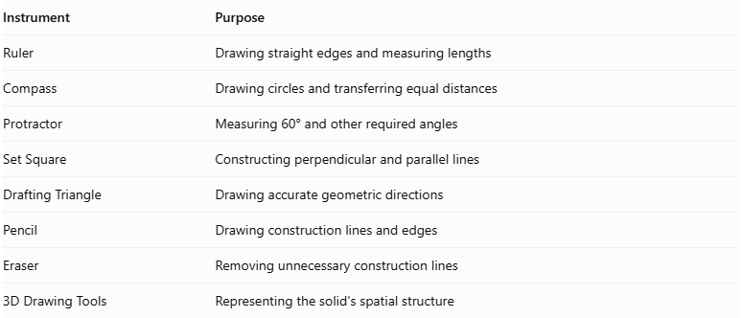
Instrument | Purpose
Ruler | Drawing straight edges and measuring lengths
Compass | Drawing circles and transferring equal distances
Protractor | Measuring 60° and other required angles
Set Square | Constructing perpendicular and parallel lines
Drafting Triangle | Drawing accurate geometric directions
Pencil | Drawing construction lines and edges
Eraser | Removing unnecessary construction lines
3D Drawing Tools | Representing the solid's spatial structure

Instrument-Based Construction Procedures
# Source: AI Source: Provided by: [Data Path: Persons Table -> ID Column: 1, Name_En Column: Motasem Essam] -> From: [ChatGPT] on [7/25/2026]
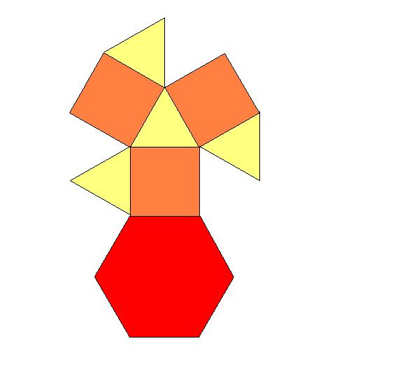

Constructing the Hexagonal Base
# Source: AI Source: Provided by: [Data Path: Persons Table -> ID Column: 1, Name_En Column: Motasem Essam] -> From: [ChatGPT] on [7/25/2026]
- Draw a circle using a compass.
- Mark six equally spaced points on its circumference using a 60° central-angle interval.
- Connect consecutive points using a ruler.
- Complete the regular hexagonal base.

Constructing the Triangular Base
# Source: AI Source: Provided by: [Data Path: Persons Table -> ID Column: 1, Name_En Column: Motasem Essam] -> From: [ChatGPT] on [7/25/2026]
- Draw an equilateral triangle using a ruler and compass.
- Ensure that its side length corresponds to the required dimensions of the standard triangular cupola.
- Position it parallel to the hexagonal base.
- Place it above the hexagonal base with the correct rotational alignment.

Constructing the Lateral Faces
# Source: AI Source: Provided by: [Data Path: Persons Table -> ID Column: 1, Name_En Column: Motasem Essam] -> From: [ChatGPT] on [7/25/2026]
- Identify the three alternating vertex groups around the hexagonal base.
- Connect the appropriate vertices of the hexagonal base to the triangular upper base.
- Construct three square lateral faces.
- Construct three equilateral triangular lateral faces between the square faces.
- Check that the triangular and square faces alternate around the solid.
- Ensure that all shared edges have matching lengths.

Finalizing the Solid
# Source: AI Source: Provided by: [Data Path: Persons Table -> ID Column: 1, Name_En Column: Motasem Essam] -> From: [ChatGPT] on [7/25/2026]
- Draw the visible edges using continuous lines.
- Represent hidden edges using dashed lines where necessary.
- Check the arrangement of all eight faces.
- Erase unnecessary construction lines.
- Complete the three-dimensional representation.
Construction note: This is an instrument-based geometric construction using rulers, compasses, protractors, and geometric relationships. It is not coordinate-based construction.

Key Points
# Source: AI Source: Provided by: [Data Path: Persons Table -> ID Column: 1, Name_En Column: Motasem Essam] -> From: [ChatGPT] on [7/25/2026]
- A Triangular Cupola has a triangular upper base and a hexagonal lower base.
- It contains 3 triangular and 3 square lateral faces.
- It has 8 faces, 15 edges, and 9 vertices.
- It is classified as a Johnson solid (J3).

Classification
# Source: AI Source: Provided by: [Data Path: Persons Table -> ID Column: 1, Name_En Column: Motasem Essam] -> From: [ChatGPT] on [7/25/2026]
Solid Geometry
└── Types of Solids
└── Cupola
└── Types of Cupolas
└── Triangular Cupola

Conclusion
# Source: AI Source: Provided by: [Data Path: Persons Table -> ID Column: 1, Name_En Column: Motasem Essam] -> From: [ChatGPT] on [7/25/2026]
The Triangular Cupola is a convex polyhedron formed by connecting an equilateral triangle and a regular hexagon with three alternating equilateral triangular faces and three square faces. It has 8 faces, 15 edges, and 9 vertices.

